 | Survival Rates and Productivity of Landbirds on Naval Station Guantanamo Bay, Cuba | 01-1715

Background:
Neotropical migratory birds are environmentally sensitive; many species have declined significantly in recent decades and are in need of enhanced management actions. Naval Station Guantanamo Bay, Cuba provides habitat for both neotropical migratory and resident birds. To help preserve these species, management plans aimed specifically at wintering survivorship and productivity were needed.

Objective:
This project, funded by the Legacy Resource Management Program, was designed to acquire information and data about landbirds in this area. This would ultimately enable land managers to effectively manage habitats to promote increased survival rates and productivity of both neotropical migratory and residential birds at Naval Station Guantanamo Bay. Education of Naval Base personnel and residents regarding the habitat was also an important element of this project. Through the promotion of good stewardship of the land, the preservation of habitat and biodiversity has been implemented.

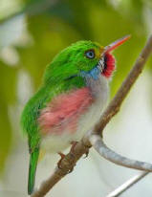
Photo by Birdseekers
Cuban Tody (Todus multicolor) – Resident Species at Naval Station Guantanamo Bay

Summary of Approach:
For two consecutive days each month throughout the year, birds were caught using up to 24 mist nets. Each bird was color-banded with up to three plastic color bands. This capture and tagging exercise was conducted at six designated study areas and each bird capture location was mapped. Study areas consisted of the four most important habitats for the neotropical migratory birds and residential birds: tropical arid forest, tropical arid scrub, palm scrub, and mangroves. Cormack-Jolly-Seber mark-recapture and mark-resighting analysis was modified to provide census information and survival rates at monthly and yearly levels for migratory and resident birds. Direct nest monitoring and analysis of population and demographic data were also studied to better determine habitat characteristics that promote high productivity and survival rates for residential and neotropical migratory birds at Guantanamo Bay.

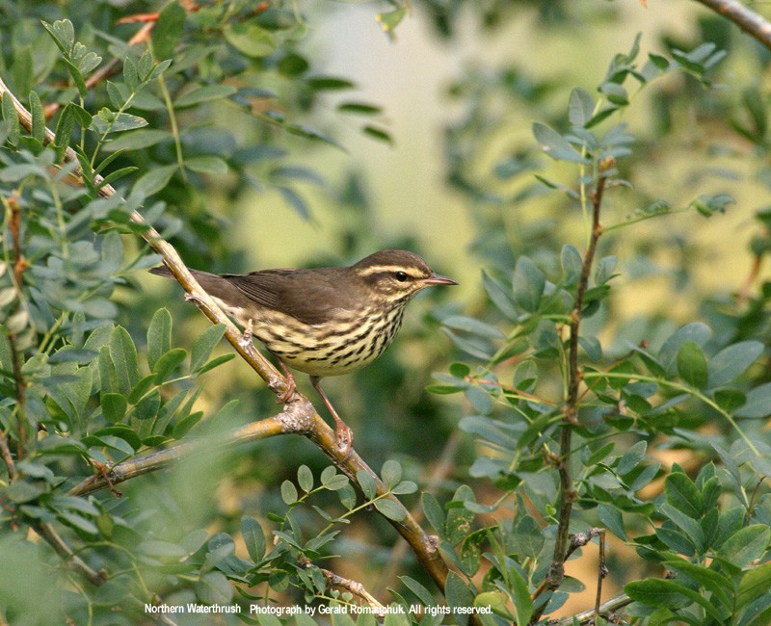
Photo by Gerald Romanchuck
Northern Waterthrush (Seiurus novaboracensis) – Neotropical Migratory Species at Naval Station Guantanamo Bay

Benefit:
DoD land make up a large part of the system of critical habitats for the declining neotropical migratory birds. The information gained from this project enables land managers on DoD installations to be better equipped to administer land management practices that result in sustainable habitats for these species. Preservation of biodiversity on military installations such as Naval Station Guantanamo Bay illustrates DoD’s commitment in the protection of their natural resources.

Accomplishments:
This project identified species of neotropical migratory birds that have been declining in their wintering grounds. The Institute for Bird Populations used the information gained from this project to educate Guantanamo Bay personnel regarding the habitat in which they work and reside. The information obtained through the successes and failures of this project provided a basis for developing a generalized field protocol for ornithologists and conservation biologists in managing neotropical bird habitat. This project also utilized outreach by educating the residents of Guantanamo Bay about these migratory and resident birds through the Navy’s environmental magazine, Currents, through bird banding demonstrations, and bird talks to base children.

Contact Information:
Dr. David DeSante
The Institute for Bird Populations
11435 State Route One, Suite 23
Point Reyes Station, CA 94956
415-663-2052; 415-663-9482 (fax)
ddesante@birdpop.org

